Smile Dental Web App

By

Iqbal

Level-6

Final Project

Table of Contents

Project Proposal 3

Goals and Objectives 3

Project Scope 3

Project Specifications 3

Target Audience 3

Project Deliverables 4

Resource Requirements 4

Project Tasks and Milestones 4

Project Assumptions 5

Project Report 5

Detail Design 6

Home Page 6

Login Page 6

Register Page 7

Branches Admin View 7

Dentists Admin View 8

Branches Visitor View 8

Dentists Visitor View 9

Booking Appointment Register View 9

Project Testing 10

User Manual 10

Summary 10

System Configuration 10

User Access Levels 10

# 

# Project Proposal

## Goals and Objectives

Smile Dental is a famous Dental clinic in New Zealand. The main goal or aim of the project is to implement an online web application named “Smile Dental Web”. The main purpose of the application is providing a way to patient book their appointment with any branch of Smile Dental clinic and find the details of all branches available. In this application there are two types of users- admin and registered visitor. Admin has different functionalities as compare to registered visitor. Admin can add, edit, delete and check details of all branches, dentists. Registered user capable to book appointment and manage its appointment.

## Project Scope

The scope of this project is to implement an app named “Smile Dental Web” with the help of which user can find any Smile Dental Clinic details as well as control their appointment with nearest branch available. The duration of the project is 20 working days which is equals to 4 weeks.

## Project Specifications

* Admin login/logout
* Add, edit, delete and check details of Branch by admin.
* Admin can delete, edit and check Dentist details.
* Admin can view all appointment details.
* Admin can register new admins.
* Registered Visitor can login/logout.
* New Visitor can register.
* Registered Visitor can control their appointment with clinic.

## Target Audience

The target audience for this project is the people who want their dental solution at single click. The age can go from 18 plus to 100 plus.

## Project Deliverables

The deliverables of the project are:

|  |  |
| --- | --- |
| **Deliverable** | **Description** |
| Final Report | This will be the final report of the project. |
| Coding | The executable code of the project will go under this. |
| Documentation | This portrays the documentation of the project. |
| Testing | All the test details will be covered in this part. |

## Resource Requirements

* Windows Operating System.
* Microsoft word for documentation.
* Asp.net MVC Framework
* 64-bit Processor and 4 GB or more RAM
* Identity framework- ASP

## Project Tasks and Milestones

|  |  |  |  |  |
| --- | --- | --- | --- | --- |
| **Tasks** | **Week-1** | **Week-2** | **Week-3** | **Week-4** |
| Brainstorming and analysis |  |  |  |  |
| Planning and initial meeting Project Proposal document. |  |  |  |  |
| Database Design and UI Design |  |  |  |  |
| Identity framework implementation |  |  |  |  |
| Coding for admin and reporter |  |  |  |  |
| Testing |  |  |  |  |
| Final Documentation and closing |  |  |  |  |

## Project Assumptions

Following are the assumption made while implementing the project:

* One admin and registered visitor will be registered by default.
* Application will be free and open source.

# Project Report

#### Functional and Non-Functional

|  |  |
| --- | --- |
| Users | Functional |
| Admin | * Login/logout * Register new admins * Admin can add, edit, delete, check details for branch of Smile Dental Clinic. * Admin can edit, delete and check details for Dentist. * Admin can view all appointment done online. |
| Customer | * Can view details of branches and all dentist details * Can control their appointment schedule. * New customers can register for free. * Login using valid credentials |
|  | Non- Functional |
|  | * High speed * Fast Loading time * High performance and security * All browsers compatibility. |

## Detail Design

### Home Page

The main landing page of the application. On navigation bar options are- Home, Branches, Dentists, Testimonials, Book Appointment, Register, Login.

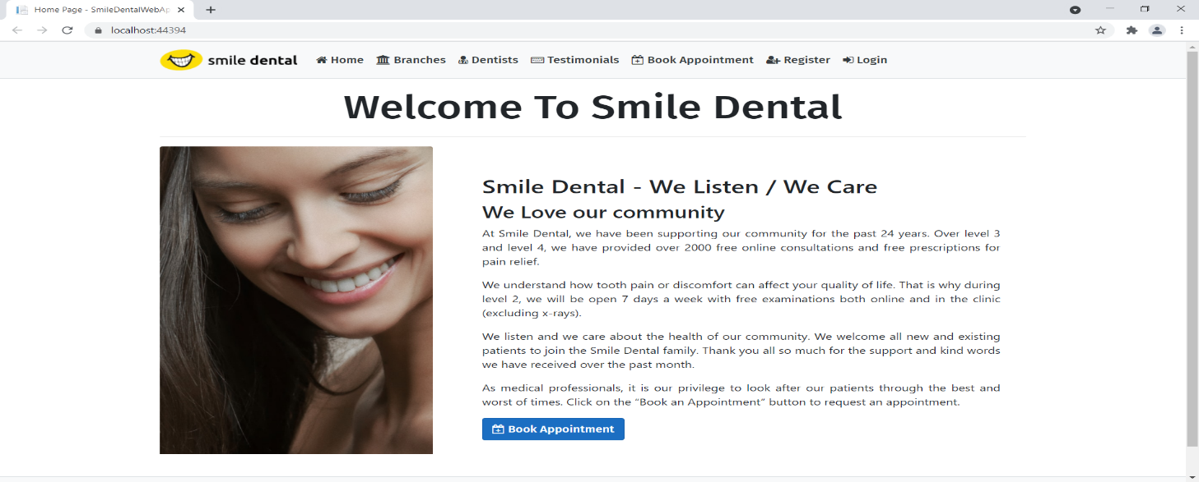

### Register Page

With the help of this page, new visitor can register to web application for book appointment

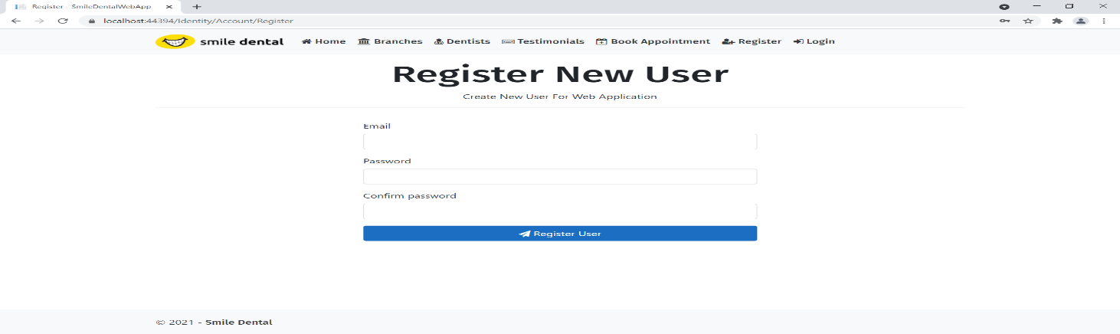

### Login Page

With the help of this page, visitor can access restricted area of web application.

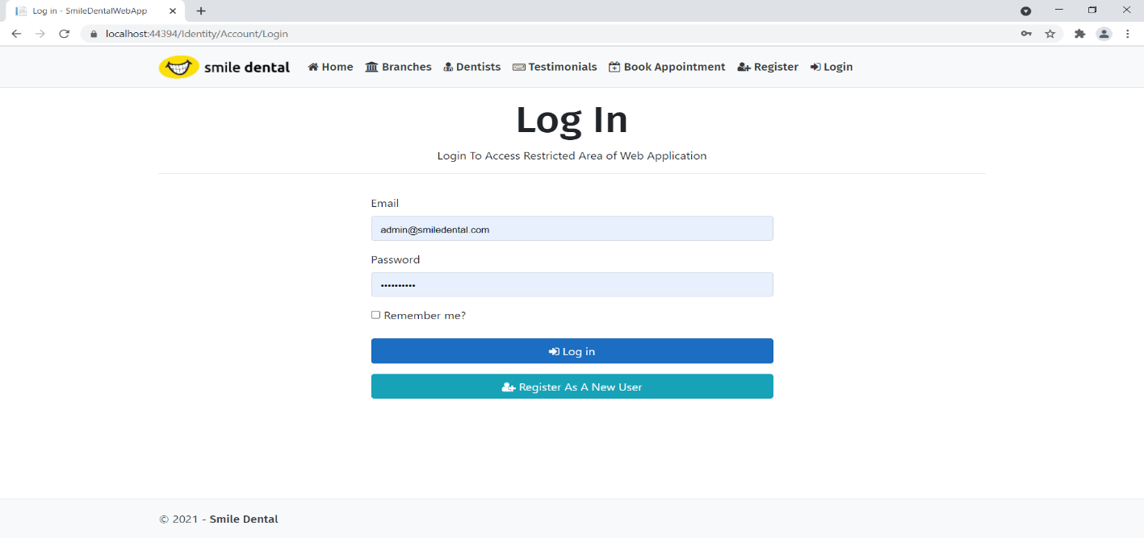

### Branches Admin View

This page highlights all the branches available on the application. Admin can delete and check details of the existing ones.

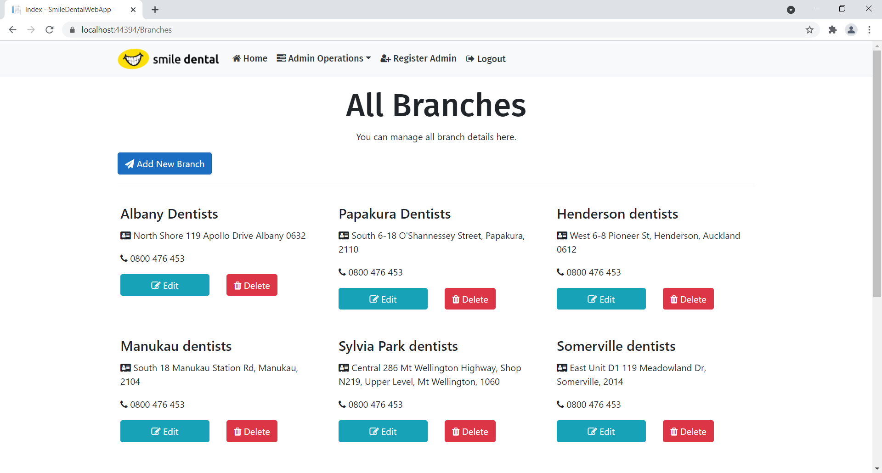

### Dentist Admin View

With the help of this page admin can manage the details of Dentists working at Smile by editing, deleting and checking their details.

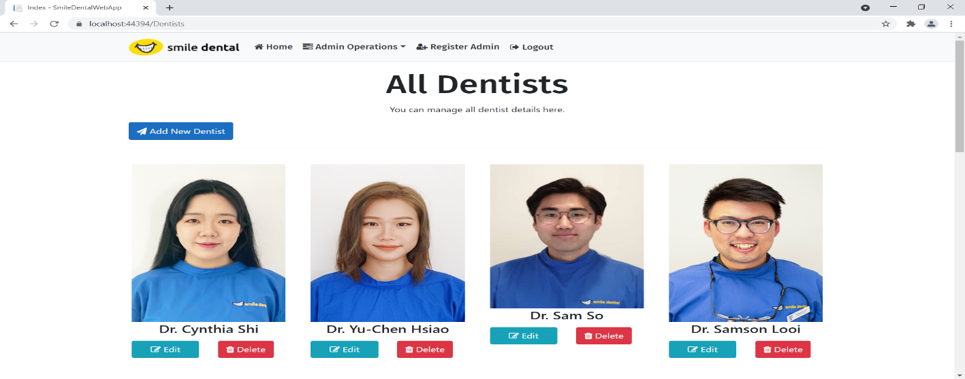

### Branch Visitor View

With the help of this page visitor can view all details of existing branches of Smile Dental.

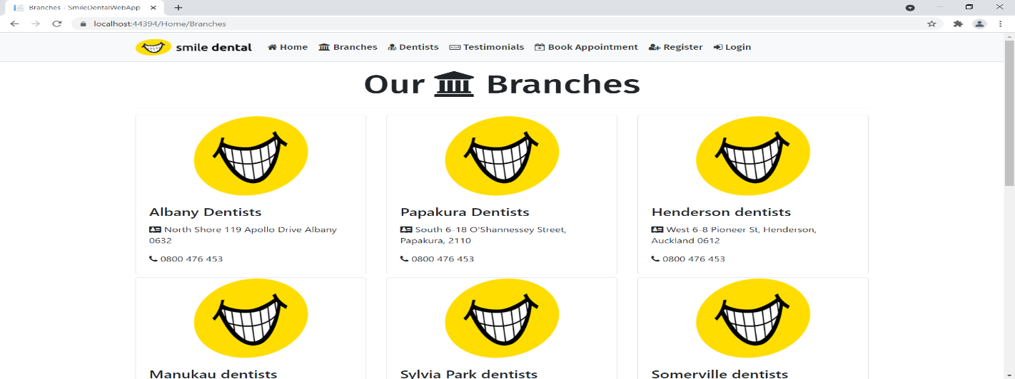

### Dentists Visitor View

With the help of this page person can view all dentist name and photo and link to further their details.

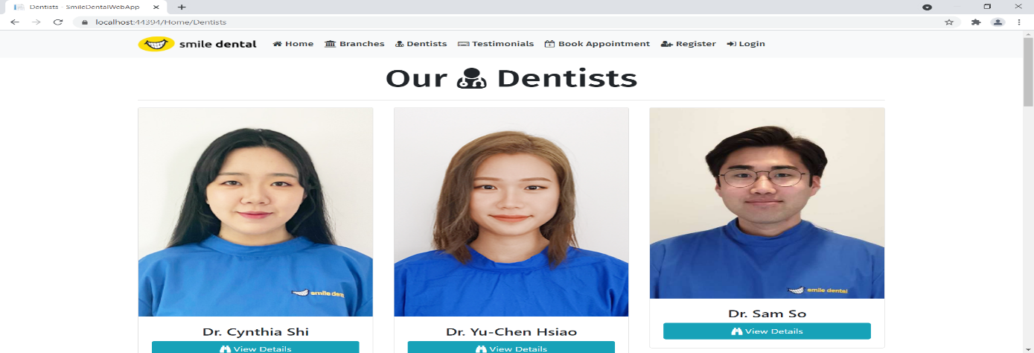

### Booking Appointment Register View

This page shows the Appointment Booking form by registered user.

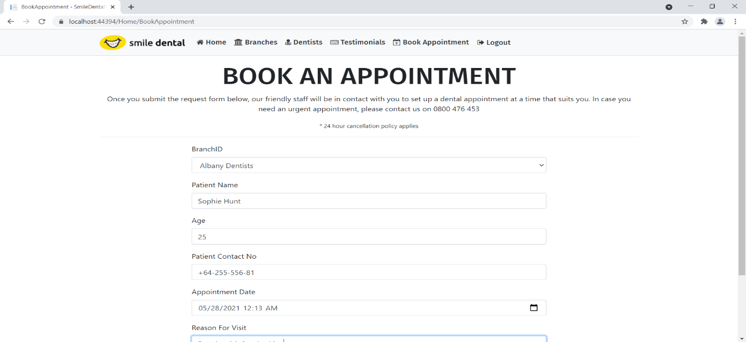

## Project Testing

The testing file for usability testing is attached as [usability test.xlsx](usability%20test.xlsx)

# User Manual

The main purpose of the application Smile Dental Web is to make a presence on internet so, patient find them easily. In this application there are two types of users- admin and registered user or visitor. Admin has different functionalities as compare to registered user. Admin can add, edit, delete and check details of branches and their dentists. Admin can also view all testimonials and appointment booked by registered user. Registered User is capable to schedule their appointment and manage them.

## Summary

### System Configuration

This app will be useful to for distributing mobile information in presentable format.

### User Access Levels

Only registered users can access the features of this application.

* **Admin:** Admin has full access of the app can register new admins.
* **Registered Visitor:** New visitor can register and existing can login using their own credentials. They have limited access.